

Self Embedding Watermarking System

**Functional Specifications and Methodology**

**Project Advisor:**

Dr. Asif Mahmood Gilani

**Group Members:**

Arbab Hamd Rizwan 18L-0756

Usama Aslam 18L-0972

Aashar Naseem 18L-1131

M. Hunzlah Malik 18L-1139

National University of Computer and Emerging Sciences

Department of Computer Science

Lahore, Pakistan

Table of Contents

List of Tables 3

List of Figures 4

1. Introduction 1

1.1 Purpose of this Document 1

1.2 Intended Audience 2

1.3 Definitions, Acronyms, and Abbreviations 2

2. General Description 3

2.1 User Characteristics 3

2.2 Domain Overview 3

3. Functionality 4

3.1 Functional Requirements 4

3.2 Non-Functional Requirements 4

3.2.1 Performance Requirements 4

3.2.2 Security Requirements 4

3.2.3 Usability Requirements 5

3.2.4 Sustainability 5

3.2.5 Reliability 5

3.2.6 Extensibility 5

3.3 Assumptions 5

4. System Architecture 6

5. Use Cases 8

5.1 Watermark Image 8

5.2 Watermark Video 9

5.3 Image Tamper Detection 10

5.4 Video Tamper Detection 11

5.5 Video Reconstruction 12

5.6 Image Reconstruction 13

6. Graphical User Interfaces 14

6.1 Add Watermark 14

6.1.1 Interface Before Image is Watermarked 14

6.1.2 Interface After Image is Watermarked 14

6.2 Upload Image 15

6.3 Upload Video 15

6.3.1 Interface Before Video is Uploaded 15

6.3.2 Interface After Video is Uploaded 16

6.4 Video Authentication 16

6.5 Video Restoration 17

7. Risk Analysis 18

7.1 Business Risk 18

7.2 Technical Risk 18

7.3 Product Risk 18

7.4 Project Risk 18

8. System Requirements 20

8.1 Hardware Requirements 20

8.2 Software Requirements 20

References 21

Appendix 22

Appendix A: Time Complexity 22

# List of Tables

Table 1: Time Complexity for Watermarking 22

Table 2: Time Complexity for Recovering 24

# List of Figures

Figure 1: High Level System Architecture 6

Figure 2: Low Level System Architecture 7

Figure 3: Interface Before Image is Watermarked 14

Figure 4: Interface After Image is Watermarked 14

Figure 5: Upload Image 15

Figure 6: Interface Before Video is Uploaded 15

Figure 7: Interface After Video is Uploaded 16

Figure 8:Video Authentication 16

Figure 9: Video Restoration 17

Figure 10: (a) Lake, (b) Baboon, (c) Lena, (d) Goodhill, (e) Sailboat, (f) Airplane 23

# Introduction

Editing software has come a long way in the last decade. As a result, the general public now has access to complex editing tools, making it easier to manipulate digital assets like photographs and movies. This casts considerable question on the credibility of any media offered. Image tampering is primarily concerned with changing the image as a whole. Video, on the other hand, is made up of multiple frames that can be regarded as individual images.

Therefore, video tampering has been categorized into two types: [1]

1. Temporal tampering refers to interframe editing manipulation. This type of tampering includes adding, removing, or changing the sequence of frames in a video.

2. Spatial tampering includes manipulating objects within a frame and is referred to as intraframe manipulation.

Watermarking is a technique that can be used to detect tampering. Our project will be focused on detecting and restoring these altered images and videos. Watermarking images entails breaking them down into smaller chunks and inserting data into the LSB, which can then be used to detect alteration and restore the original image. Numerous approaches are investigated in research publications, varying depending on the number of blocks the image is divided into and the watermarking method [2 - 4]. By first detecting the keyframes and then processing those frames as if they were images, this approach can also be utilized on video [1].

## Purpose of this Document

This project aims to successfully detect tampering in any image or video and reconstruct them to their original state. We have made extensive use of Digital Image Processing (DIP) concepts in this project. This will be helpful in many areas, such as copyright infringement of content on social media. Moreover, this project will also be an essential asset in law enforcement agencies where CCTV footage is presented as evidence. Our project can help place watermarks on such footage and will successfully detect any tampering done by some third party to erase any concrete evidence from the footage. We have studied various watermarking algorithms from research papers mentioned in the reference section. However, the main watermarking algorithms used will include the use MD5 hashing function [5] to self-embed the watermark into an image.

Additionally, we have made use of this same methodology to watermark videos. The main idea is to identify the keyframes from a window of frames and watermark that frame according to the same algorithm used to watermark the image [1]. We will perform watermarking methods on pictures and videos to later be detected for any tampering through our system. In case of any tampering, the watermarked image or video will be recovered depending on the percentage of tampering.

## Intended Audience

This document is intended for our team of developers, the FYP supervisor, the evaluation team, and the FYP coordinator. All of the people mentioned above are the document's intended audience because they are all involved in this project.

## Definitions, Acronyms, and Abbreviations

CZ refers to the central cropping attack on an image (center of image) . VCZ means vertical center attack on an image. Square image refers to an n×n dimension image where n is any positive number. For example, 256×256 or 512×512 image dimensions have been used for experimental setup. Image tampering includes cropping attacks and editing attacks on an image. Video tampering includes object removal attacks on video frames. Key frames are selected from a window of frames which have the most amount of information of that specific window of frames.

# General Description

## User Characteristics

Most people who work with photos, videos, social media users, and law enforcement agencies will use our Self Embedding Watermarking System. Because editing tools are widely available on the internet and it is relatively simple to modify and alter a photo or video to suit one's needs, this can lead to problems and fake scandals, causing people's reputations to be ruined. This is especially true for well-known individuals, such as celebrities, who are also very active on social media. On the other hand, law enforcement agencies can use this system to determine whether evidence has been tampered with and, if desired, restore the video or image to its original state. So, using our system, users will be able to authenticate the video and image, and if it has been forged, they will be able to restore it.

## Domain Overview

The Self Embedding Watermarking System has two main features: tamper detection and media restoration. The media, in this case, includes both images and videos. The system first allows the user to upload an image or video, after which the user can choose whether he only wants to use tamper detection, watermark an image or video, or restore an image or video that has been watermarked. To begin, if the user only wants to detect tampering in the media, a new tab is opened, and the result is displayed. Second, if the user wishes to watermark an image or video, the media is watermarked, and the user is given the option to download the watermarked media. Finally, if the user wishes to restore a watermarked media, he or she should upload it, and the system will open another tab with the option to download the restored media. So, in a nutshell, our system enables its users to authenticate a video or an image, watermark a video or an image, and finally, restore a video or an image to its original state.

# Functionality

The functional requirements can be divided between the user and the watermarking system.

## Functional Requirements

1. The system shall allow the user to place a watermark in an image or video.
2. The system shall allow the user to download watermarked images or videos.
3. The system shall allow the user to detect any tampering in watermarked images or videos.
4. The system shall allow the user to view detection results on tampered images or videos.
5. The system shall allow the user to reconstruct tampered images or videos that have been watermarked by the system.
6. The system shall allow the user to download reconstructed images or videos.
7. The system shall generate reports on tampered regions of watermarked images or videos.

## Non-Functional Requirements

The following are non-functional requirements identified for the system:

### 3.2.1 Performance Requirements

The System shall meet the following performance requirements:

* The system shall limit the size of the uploaded images or videos to 50MB.
* The system webpage shall load in 2 seconds.
* The system shall take an approximate time of 180 seconds (3 minutes) to embed watermark in an image [4].
* The system shall take an approximate time of 180-199 seconds to recover tampered image depending on the percentage of tampering that ranges from 25% - 75% (see Appendix A) [4].

### 3.2.2 Security Requirements

The system shall meet the following security requirements:

* The system shall run image or video processing algorithms on server side to maintain secrecy of watermarking and reconstruction algorithms.
* The system shall use a permutation key to place watermarks on images.

### 3.2.3 Usability Requirements

The following usability requirements shall be met by the system:

* The system shall provide an easy to learn and navigate user interface.
* A consistent theme shall be used throughout the system.

### 3.2.4 Sustainability

* The system shall be accessible from any computer browser assuming the hardware and software specifications mentioned in hardware and software requirements are met.

### 3.2.5 Reliability

* The system shall have a 100% uptime guarantee.

### 3.2.6 Extensibility

* The system shall be generic i.e., it shall work with most image or video formats.

## Assumptions

The following assumptions have been taken into consideration while designing the specifications for this system:

* The user shall upload images or videos having size maximum of 50MB.
* The system server shall create an instance container for each user to lessen the load on the main server, however this will increase the cost of the server.
* The user shall upload an image having nxn dimensions i.e. a square image.
* The cost of the server shall increase proportionally to the number of users.

# System Architecture

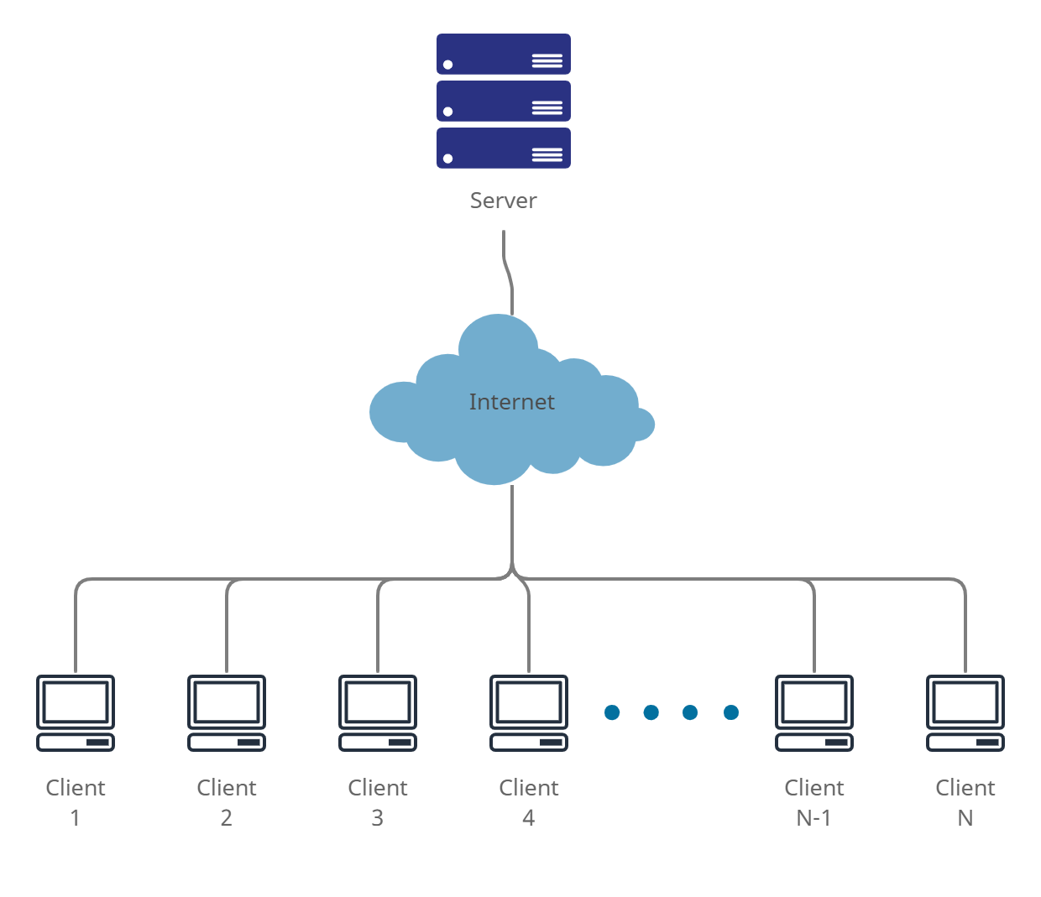

**Figure 1: High Level System Architecture**

*Figure shows high level system architecture (client-server architecture)*

The high-level architecture for our system is shown in figure 1. We will follow the client-server architecture for our system. Users shall be able to access the system website from the internet and send their requests to the server through the website. The server will process user requests accordingly and respond to their requests. For our system, there will only be one type of user, i.e., client, because there is no need for a backend database and an admin to manage the database and client information. The client will only send requests to the server by uploading an image or video, and the server will process the request in the backend and respond while creating no entry on any database.

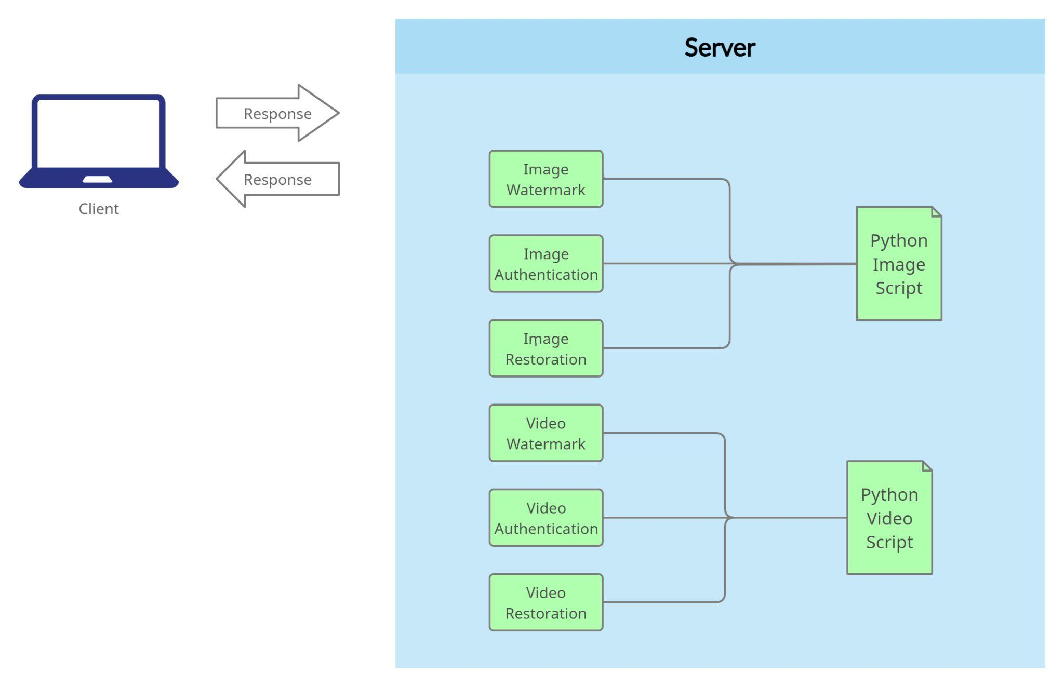

**Figure 2: Low Level System Architecture**

*Figure shows low level architecture of the system (client-server)*

Figure 2 shows the low-level architecture of our system. As mentioned above, the client will directly interact with the server by sending requests to the server. The server will handle all the processing load for each user. The user will upload an image or a video, and according to the type of request, the server will act accordingly by processing the image or video. The server will forward the request for further processing depending on whether the user uploaded an image or a video. In the case of an image, the server chooses from three different modules, i.e., image watermark, image authentication, and image restoration. These are computed through the Python scripts on the server-side, which contain algorithms for respective modules. This same process is followed for video uploads.

# Use Cases

Following are the main use cases of the system.

## Watermark Image

|  |  |  |  |  |
| --- | --- | --- | --- | --- |
| **Name** | | Watermark Image | | |
| **Actors** | | User | | |
| **Summary** | | The user shall upload an image which will then be watermarked by the system. | | |
| **Pre-Conditions** | | None | | |
| **Post-Conditions** | | The page reloads and the user can download the watermarked image from the same page. | | |
| **Special Requirements** | | Max image size is 50MB, dimensions of image should be n×n | | |
| **Basic Flow** | | | | |
| **Actor Action** | | | **System Response** | |
| 1 | User uploads an image. | | 2 | Place a watermark on the image. |
| **Alternative Flow** | | | | |
| 3 | The user uploads an image which exceeds the limit. | | 4-A | The system responds with an error message: *Image size too large.* |

## 

## Watermark Video

|  |  |  |  |  |
| --- | --- | --- | --- | --- |
| **Name** | | Watermark video | | |
| **Actors** | | User | | |
| **Summary** | | The user shall upload a video which will then be watermarked by the system. | | |
| **Pre-Conditions** | | None | | |
| **Post-Conditions** | | The page reloads and the user can download the watermarked video from the same page. | | |
| **Special Requirements** | | Max image size is 50MB, dimensions of image should be n×n | | |
| **Basic Flow** | | | | |
| **Actor Action** | | | **System Response** | |
| 1 | User uploads a video. | | 2 | The system places a watermark on the video. |
| **Alternative Flow** | | | | |
| 3 | The user uploads a video which exceeds the limit. | | 4-A | The system responds with an error message: *Video size too large.* |

## Image Tamper Detection

|  |  |  |  |  |
| --- | --- | --- | --- | --- |
| **Name** | | Image Tamper Detection | | |
| **Actors** | | User | | |
| **Summary** | | The user shall upload a watermarked image which will then be processed by the system to detect any kind of tamper to the image | | |
| **Pre-Conditions** | | The image must be watermarked by the system. | | |
| **Post-Conditions** | | Users shall be able to view reports of tampering. | | |
| **Special Requirements** | | Image size must not be larger than 50MB. | | |
| **Basic Flow** | | | | |
| **Actor Action** | | | **System Response** | |
| 1 | User uploads an image. | | 2 | System processes the image and notifies the user if it is tampered. |
| **Alternative Flow** | | | | |
| 3 | Users upload an image which exceeds the limit. | | 4-A | The system responds with an error message: *Image size too large* |

## 

## Video Tamper Detection

|  |  |  |  |  |
| --- | --- | --- | --- | --- |
| **Name** | | Video Tamper Detection | | |
| **Actors** | | User | | |
| **Summary** | | The user shall upload a watermarked video which will then be processed by the system to detect any kind of tamper to the video | | |
| **Pre-Conditions** | | The video must be watermarked by the system. | | |
| **Post-Conditions** | | Users shall be able to view reports of tampering. | | |
| **Special Requirements** | | Video size must not be larger than 50MB. | | |
| **Basic Flow** | | | | |
| **Actor Action** | | | **System Response** | |
| 1 | User uploads a video. | | 2 | System processes the video and notifies the user if it is tampered. |
| **Alternative Flow** | | | | |
| 3 | Users upload a video which exceeds the limit. | | 4-A | The system responds with an error message: *Video size too large* |

## 

## 

## 

## Video Reconstruction

|  |  |  |  |  |
| --- | --- | --- | --- | --- |
| **Name** | | Video Reconstruction | | |
| **Actors** | | User | | |
| **Summary** | | The user shall upload a watermarked video which will then be processed by the system to reconstruct. | | |
| **Pre-Conditions** | | The video must be watermarked by the system. | | |
| **Post-Conditions** | | Users shall be able to download recovered video. | | |
| **Special Requirements** | | Video size must not be larger than 50MB. | | |
| **Basic Flow** | | | | |
| **Actor Action** | | | **System Response** | |
| 1 | User uploads a video. | | 2 | System processes the tampered video and reconstructs the original video for the user to download. |
| **Alternative Flow** | | | | |
| 3 | Users upload a video which exceeds the limit. | | 4-A | The system responds with an error message: *Video size too large* |

## Image Reconstruction

|  |  |  |  |  |
| --- | --- | --- | --- | --- |
| **Name** | | Image Reconstruction | | |
| **Actors** | | User | | |
| **Summary** | | The user shall upload a watermarked image which will then be processed by the system to reconstruct. | | |
| **Pre-Conditions** | | The image must be watermarked by the system. | | |
| **Post-Conditions** | | Users shall be able to download recovered images. | | |
| **Special Requirements** | | Image size must not be larger than 50MB. | | |
| **Basic Flow** | | | | |
| **Actor Action** | | | **System Response** | |
| 1 | User uploads an image. | | 2 | System processes the tampered image and reconstructs the original image for the user to download. |
| **Alternative Flow** | | | | |
| 3 | User uploads an image which exceeds the limit. | | 4-A | The system responds with an error message: *Image size too large* |

# Graphical User Interfaces

This section provides a prototype GUI of the project.

## 6.1 Add Watermark

### 6.1.1 Interface Before Image is Watermarked

**Figure 3: Interface Before Image is Watermarked**

*Figure shows the user interface for before watermarking an image*

### 6.1.2 Interface After Image is Watermarked

**Figure 4: Interface After Image is Watermarked**

*Figure shows the user interface for after an image has been watermarked*

## 6.2 Upload Image

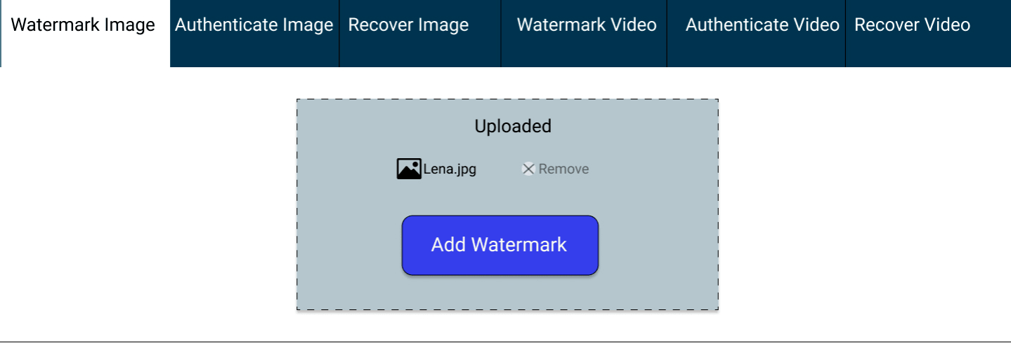

**Figure 5: Upload Image**

*Figure shows the user interface for uploading an image*

## 6.3 Upload Video

### 6.3.1 Interface Before Video is Uploaded

**Figure 6: Interface Before Video is Uploaded**

*Figure shows the user interface for before uploading a video*

### 6.3.2 Interface After Video is Uploaded

**Figure 7: Interface After Video is Uploaded**

*Figure shows the user interface for after uploading a video*

## 6.4 Video Authentication

**Figure 8:Video Authentication**

*Figure shows the user interface after authenticating a video*

## 6.5 Video Restoration

**Figure 9: Video Restoration**

*Figure shows the user interface for after video restoration*

# 

# Risk Analysis

Risk analysis is critical in any project because it alerts us to potential future defaults in the system and allows us to make early efforts to resolve those risks. The following subsections explain the various risks associated with our project.

## 7.1 Business Risk

The business risk associated with our project is that we must create a product that is superior to any other on the market in order to satisfy the customer. Another risk is keeping an eye out for the competitor so that the customer is not drawn to them. Finally, the greatest risk is that when our customers use our product, they do not perceive that our software is not providing them with satisfactory results, which could lead to our product's reputation being ruined.

## 7.2 Technical Risk

The technical risks in our project are that we must first ensure that we use only software process models in the software development life cycle that will make our product the most productive. Another risk associated with our project is that we must select appropriate testing procedures to rigorously test our product and identify and correct most of the system's defects.

## 7.3 Product Risk

The product risks in a software product are to ensure that the product built is reliable, has excellent performance, and is of the highest quality. In the case of our project, we must ensure that the product we created is always functional and does not fail. It is also our team's responsibility to ensure that the system's security meets the standards. Finally, it is our responsibility to ensure that all of the system's specified features are included in the final product.

## 7.4 Project Risk

The project risk is ensuring that our project's resources are properly managed, which includes both human and technical resources. In our project, we must ensure that all members are available during the project's development and that if something unexpected occurs, the other members can handle it. Another thing to keep an eye out for is that the tasks are completed on time. Finally, if a team member lacks the necessary skills to develop the product, he should learn the essential skills.

# System Requirements

The project shall require the following hardware and software requirements:

## Hardware Requirements

The hardware requirements for the usage of this system are the following:

* Cloud server for the deployment of the system. The server will be responsible for handling the complex computations of images or videos.
* A GPU, preferably GTX 1050 Ti.
* CPU Intel Core i5-7500 (or higher) 3.40 GHz.
* 4GB RAM or higher.

## Software Requirements

The software requirements for the usage of this system are the following:

* NodeJS
* ReactJS
* Bootstrap 5
* Python
* Django
* JavaScript, specifically TypeScript
* Ant Design UI

# References

[1] V. Amanipour and S. Ghaemmaghami, "Video-Tampering Detection and Content Reconstruction via Self-Embedding," in IEEE Transactions on Instrumentation and Measurement, vol. 67, no. 3, pp. 505-515, March 2018, doi: 10.1109/TIM.2017.2777620.

[2] Gul, E., Ozturk, S. A novel hash function based fragile watermarking method for image integrity. Multimed Tools Appl 78, 17701–17718 (2019). https://doi.org/10.1007/s11042-018-7084-0

[3] Gul, E., Ozturk, S. A novel pixel-wise authentication-based self-embedding fragile watermarking method. Multimedia Systems 27, 531–545 (2021). https://doi.org/10.1007/s00530-021-00751-3

[4] Gul, E., Ozturk, S. A novel triple recovery information embedding approach for self-embedded digital image watermarking. Multimed Tools Appl 79, 31239–31264 (2020). https://doi.org/10.1007/s11042-020-09548-4

# Appendix

## Appendix A: Time Complexity

**Table 1: Time Complexity for Watermarking**

*Following table shows time complexity for watermark embedding process*

|  |  |  |  |
| --- | --- | --- | --- |
| Image | Watermark embedding time (sec) | | |
| Recovery bits embedding | Authentication bits embedding | Total watermark embedding |
| Lena | 133.128627 | 48.839553 | 179.968180 |
| Sailboat | 132.485935 | 46.644259 | 179.130194 |
| Lake | 132.879485 | 46.652739 | 179.532224 |
| Airplane | 132.357713 | 46.389058 | 178.746771 |
| Baboon | 133.314231 | 46.128864 | 179.443095 |
| Goodhill | 133.624994 | 46.151119 | 46.151119 |

Time complexity for watermark embedding is given in table 1. The images mentioned in the table are given below. All the mentioned images are square images, i.e., they have n×n dimensions. For the images mentioned in the table, the dimensions are 512×512. The computing time for watermark embedding depends on the size of the image. This is due to the whole image being divided into various blocks. These experiments have been conducted on a CPU Intel Core i5-7500 3.4 GHz with 4GB RAM and a GTX 1050 ti GPU [1]. Hence the processing time might be reduced depending on a higher specs CPU and GPU.

|  |  |  |
| --- | --- | --- |
|  |  |  |
| **(a)** | **(b)** | **(c)** |
|  |  |  |
| **(d)** | **(e)** | **(f)** |

**Figure 10: (a) Lake, (b) Baboon, (c) Lena****, (d) Goodhill, (e) Sailboat, (f) Airplane**

*Figure shows the square images used for experimental setup*

For the process of recovering these watermarked images, the time complexity varies according to the amount of tampering done in the image. The details are mentioned in table 2. Maximum limit for image recovery is 75% which takes the longest time to recover.

**Table 2: Time Complexity for Recovering**

*Following table shows the time complexity for image recovering process*

|  |  |  |  |
| --- | --- | --- | --- |
| Image | Tamper detection and recovery time (sec) | | |
| 25% CZ | 50% VCZ | 75% CZ |
| Lena | 180.296284 | 189.142496 | 198.514490 |
| Sailboat | 180.821834 | 190.707774 | 199.018766 |
| Lake | 179.811014 | 189.824777 | 199.324460 |
| Airplane | 180.477713 | 188.998814 | 198.762606 |
| Baboon | 180.199268 | 189.820586 | 198.406937 |
| Goodhill | 180.330294 | 189.730310 | 189.730310 |